Privacy Information and Consent Form

Dear Participant,

At the Social Science Research Centre, we consider it an important goal to provide as accurate a description as possible of the way in which Hungarian society works. To do this, we try to use innovative research methods. People are spending more and more time on social media channels, writing posts, uploading pictures, searching for things, and responding to posts by people they know and don't know. These activities are stored and used by social media companies to improve their services. However, the resulting data is also very valuable from a research point of view, as it can answer questions that traditional survey research cannot.
Social media companies are obliged to make the user data they store available to users. Users can view, download, and even share their own data with others. Sharing social media data for research purposes is called data donation. We invite you to participate in such data donation research. For your social media data, we ask you to share your Facebook and Google data (YouTube, Google searches, location data) with us, and you also have the option to share your Twitter, Instagram, and TikTok data with us if you are present on these social media platforms. Our research does not involve your very sensitive data, so for instance, for Facebook, we do not ask you to share your messages (Facebook Messenger). The technical details of sharing and the exact list of data requested to be shared are set out in the annex of this information form.
In addition to sharing your digital data, we would also like to invite you to complete an online questionnaire. Based on social media data and the survey, we will study the following research questions.

- The emergence of political and media echo chambers in the online space
- Mental health research based on social media data
- Traces of keeping pets in the digital space
- Stratification and class structure in social media
- Tracing musical tastes on social media
- Self-representation across different social media platforms
- The impact of COVID-19 in the digital space
- Online patterns of religiosity
- Validity of using digital and survey data in research (comparative analysis)

We plan to present the research results at conferences and produce scientific papers based on the data. The research is carried out by the Social Science Research Centre and the data collection is funded by the Eötvös Loránd Research Network. CEU and ELTE researchers are involved in the research alongside colleagues from the Centre for Social Sciences. The research is led by Zoltán Kmetty, Senior Research Fellow at the Centre for Social Sciences (kmetty.zoltan@tk.hu).

In the consent form you fill in, you can specify exactly what we can do with the data you provide. The data will only be disclosed in aggregate form, and no personal data or data that can be used to personally identify you will be omitted from any results or data disclosed. The data will be used primarily by the researchers involved in the research; external researchers will only have access to strictly anonymised and aggregated data after approval of their research design by the research supervisor.

The data you share, when uploaded, will be stored on the server of the NRC company that uploaded it. After a technical check of the uploaded data (to ensure that all the necessary data has been uploaded), the data will be transferred to the NRC's own server. The contracted company will not be allowed to store the uploaded data in any other form, will not be allowed to make copies of it and will be obliged to ensure that it is removed from its own server within a maximum of 10 days after the transfer of the data.

Personally identifiable information is only retained in the first processing step, after which it is deleted from our server. A separate procedure will be set up to handle data that may be used to identify respondents individually:
- The names that appear in the database are rendered unrecognisable in the first step of data processing and the raw databases are pre-processed. Raw databases are not kept.
- When uploading Instagram data, images and videos can be included in the research database. Videos will be deleted and images will be software blurred to exclude people from possible identification.
- In the location data received, after pre-processing (identification of public POIs), the coordinates are randomly changed using an algorithm so that locations that can be linked to individual persons cannot be identified.

Access to anonymised data is also severely restricted, with project researchers only receiving the processed data they need for their own research questions. The research does not pose any risk to participants under the data handling described. We do not report results on individual subjects in our publications.

It is important to stress that your participation in the research is voluntary. You can opt out of the research at any time and ask for your data to be deleted. You can also request information about what data we hold about you at any time. As all personal data will be removed during the research, you will receive an identification number at the beginning of the research. This will enable us to identify you at the later stages of the research and to delete the data we hold about you on request. If you have any questions, please contact us or give us a call.

Email address of the research: adatdonacio@tk.hu

The research has been approved by the Research Ethics Committee of the Centre for Social Sciences under the number 1-FOIG/130-37/2022.

The Data Protection Officer (Dr Zsuzsa Kerekes) is responsible for the protection of research data at the Centre for Social Sciences. In case of questions or problems you can contact her. Her email address is: kerekes.zsuzsa@tk.mta.hu. The Data Protection and Security Policy of the Centre for Social Science Research can be found at the following link:
https://tk.hu/uploads/files/ADATVEDELMI_ES_ADATBIZTONSAGI_SZABALYZAT(1).pdf

In the event of a complaint about data processing, you can directly contact the National Authority for Data Protection and Freedom of Information (1055 Budapest Falk Miksa u. 9-11; www.naih.hu), or in the event of unlawful data processing, you can initiate a civil action before the competent court (http://birosag.hu/torvenyszekek).

Declaration of consent
I hereby declare that I have received and read the Privacy Policy of the Centre for Social Science Research on New Ways of Knowing Society - The Potential of Donation-Based Digital Data Collection, that I have been informed about the Centre for Social Science Research's Privacy and Data Security Policy and its electronic availability.

I have been informed that NRC, the data controller involved in the collection of this statement and in the conduct of the research, is the data processor legally involved in the research.

To manage my research data

O I agree O I do not agree

Annex
Technical description of data sharing

Facebook
To download the data from your Facebook account, please follow the steps below.
The information in your profile must first be requested on Facebook. You can request the data using a desktop or laptop computer from a web browser.

Start exporting your Facebook profile
- Visit facebook.com in your web browser from a laptop or desktop computer.
- If necessary, log in to the site with your Facebook (Meta) profile.
- Click on your profile picture in the top right corner, then click on Settings & Privacy in the menu that appears.
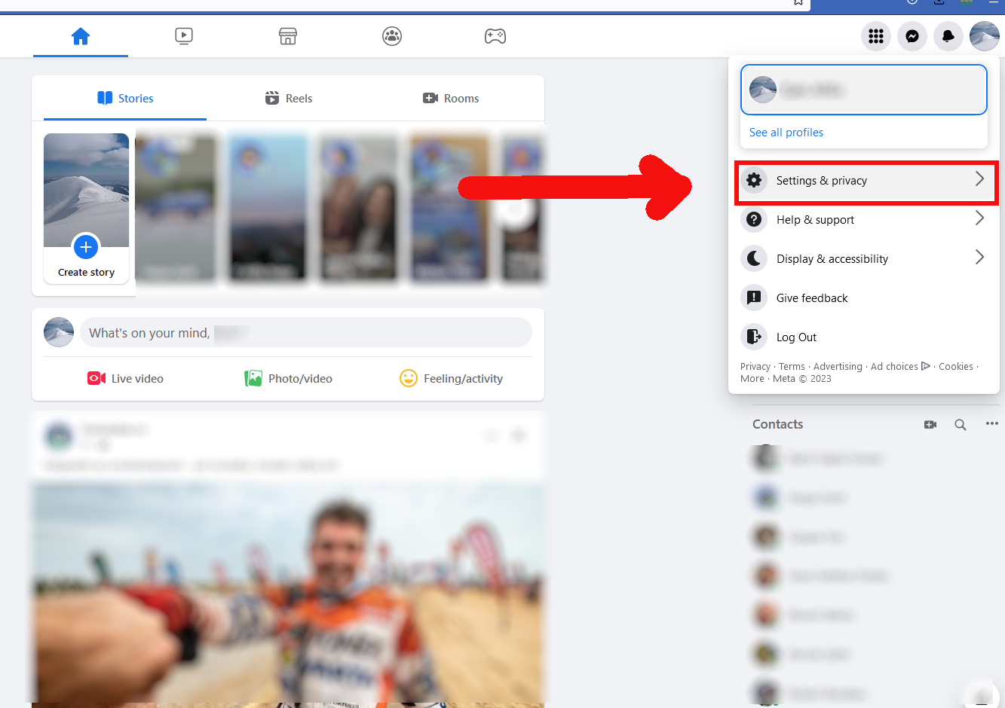
- In the menu that appears, click Settings.
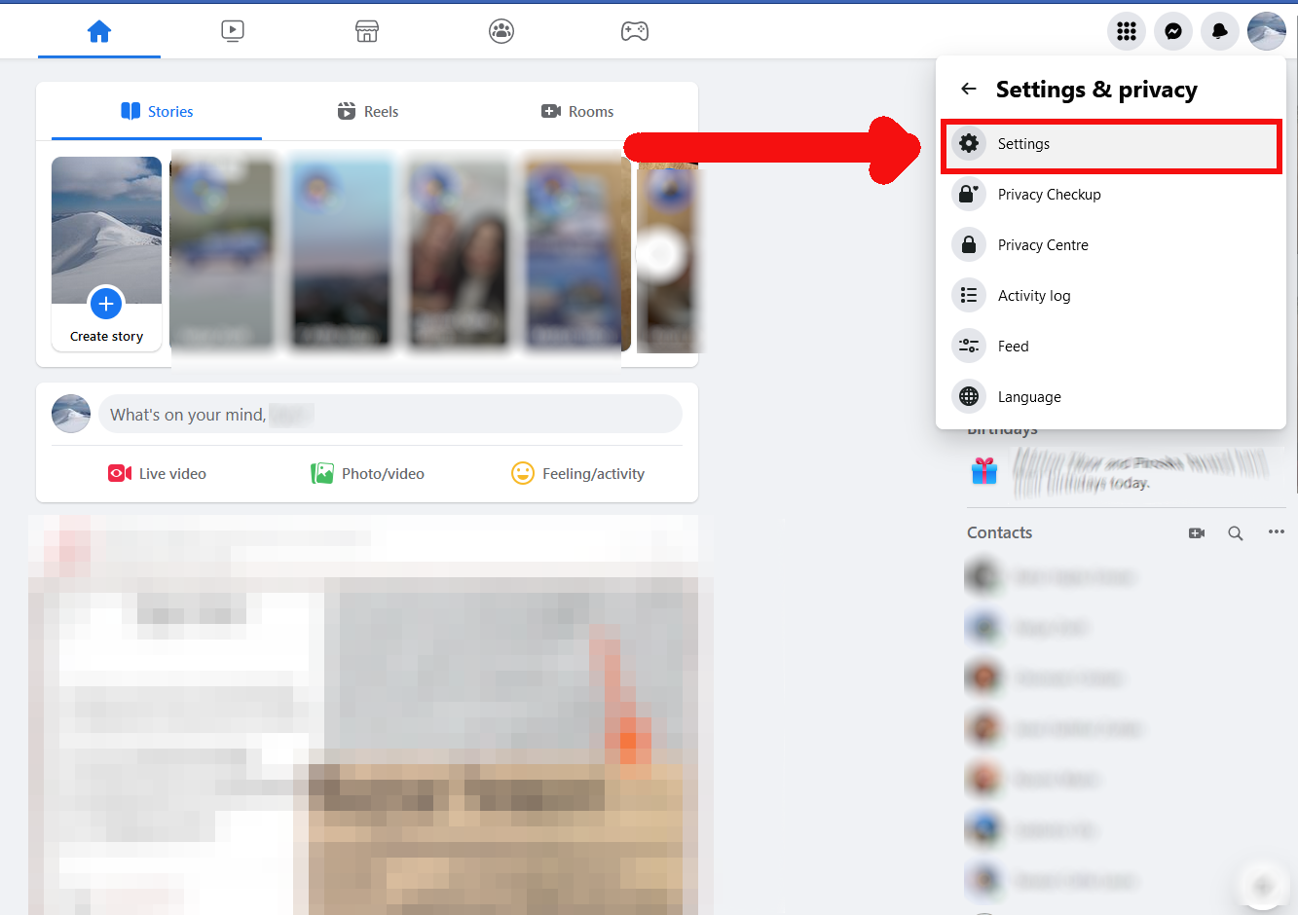
- If you see such a menu item, in the left menu bar, click on Your Facebook information and to step 8 in the description.
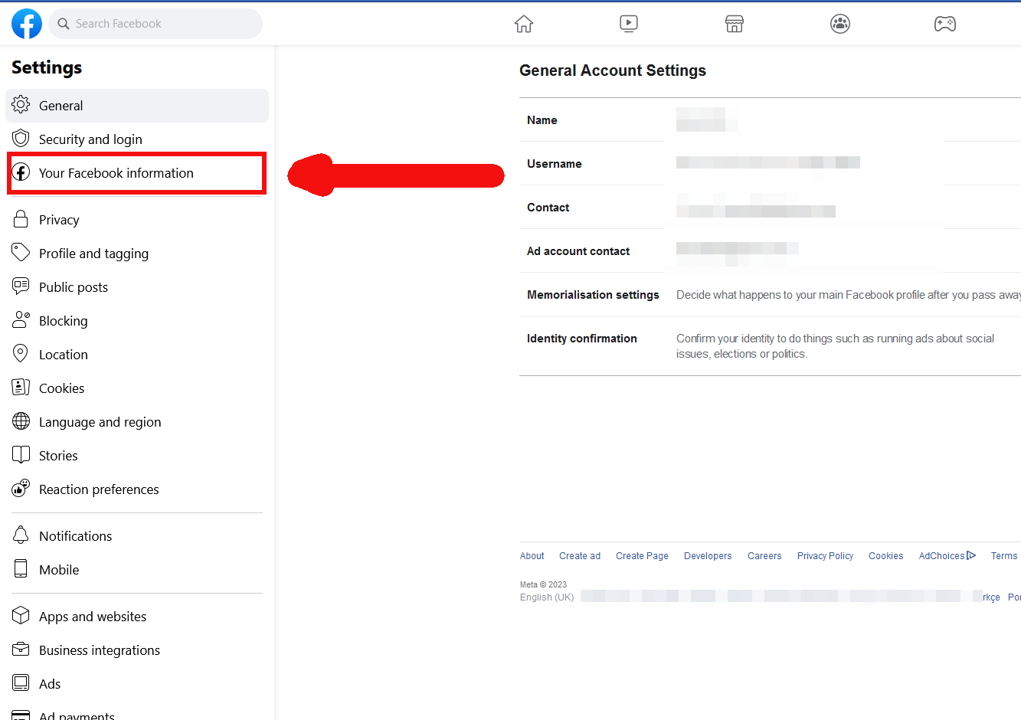

- If you do not see this menu item, you can also click on the Privacy tab in the menu on the left.

- In the menu on the left, click the Your Facebook information tab.

- In the Download your information (this section might appear under a different name) section, click on the View button.
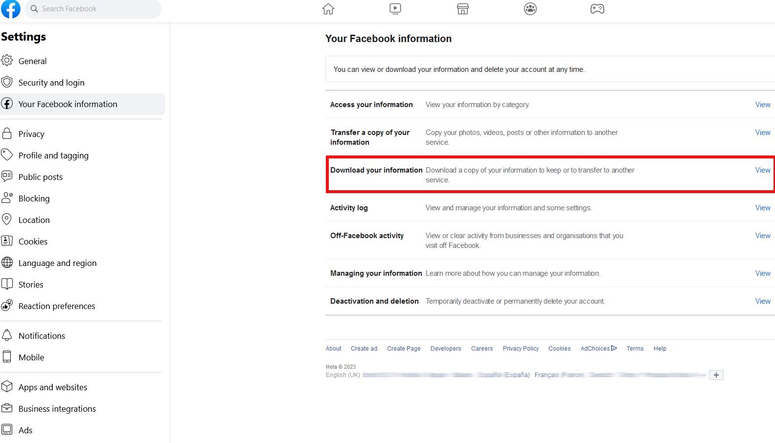
- In the interface that appears, you must first enter the file settings for the archive. In the Format menu, select JSON, and in the Date range menu, select All time. (The Media quality field does not need to be changed, it can remain at the default "High" option.)
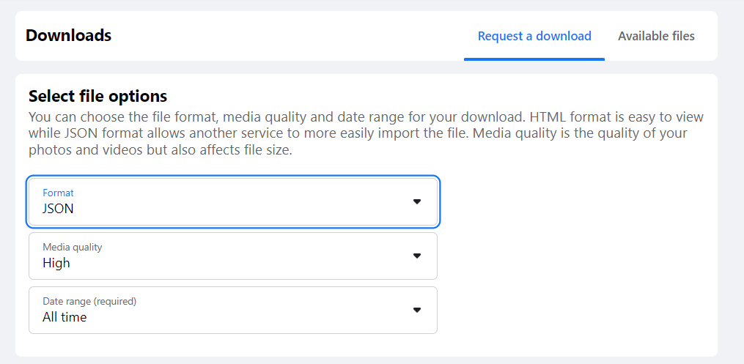

- Then click Deselect All in the Select information to download section.
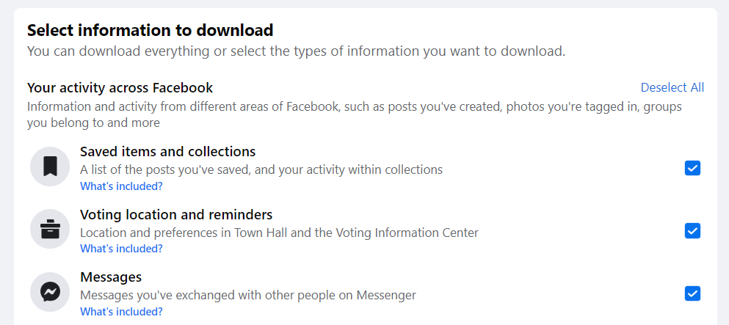

- This will uncheck all the checkboxes on the right. Please now select and tick the following categories from the list. You will need to tick a total of 20 boxes, as follows.
Your activities on Facebook
 | Posts
 | Pages and profiles
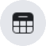 | Events
 | Comments and reactions
 | Stories
 | Reels
 | Groups
 | Reviews
 | Other activity
Personal data
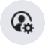 | Profile information
 | Other personal information
Contacts
 | Friends and followers
Logged data
 | Your topics
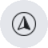 | Location
 | Music recommendations
 | Search
 | Your interactions on Facebook
Settings
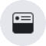 | Feed
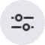 | Preferences
Advertising information
 | Ads information

- Please check carefully that you have selected all the categories listed above!
- Then please hit the Request a download button at the bottom of the page.
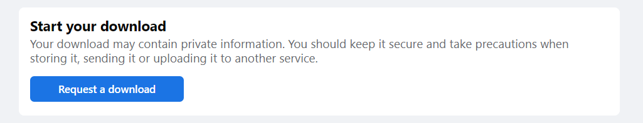
- You will then see a message in the bottom left-hand corner with the text A copy of your information is being created, and you will also receive an email with the subject Facebook information file is requested.
- You will be able to download your Facebook data when you receive a notification by email to the address you have provided. Depending on the size of your profile, it can take anywhere from a few minutes to 2-3 days for your archive to be available.

Download Facebook profile archive
- Go to your mailbox and open the email with the subject Your Facebook information file is ready.
- Click on the Download Your Information link in the mail.
- In the interface that appears, click the Available files button in the top right corner.
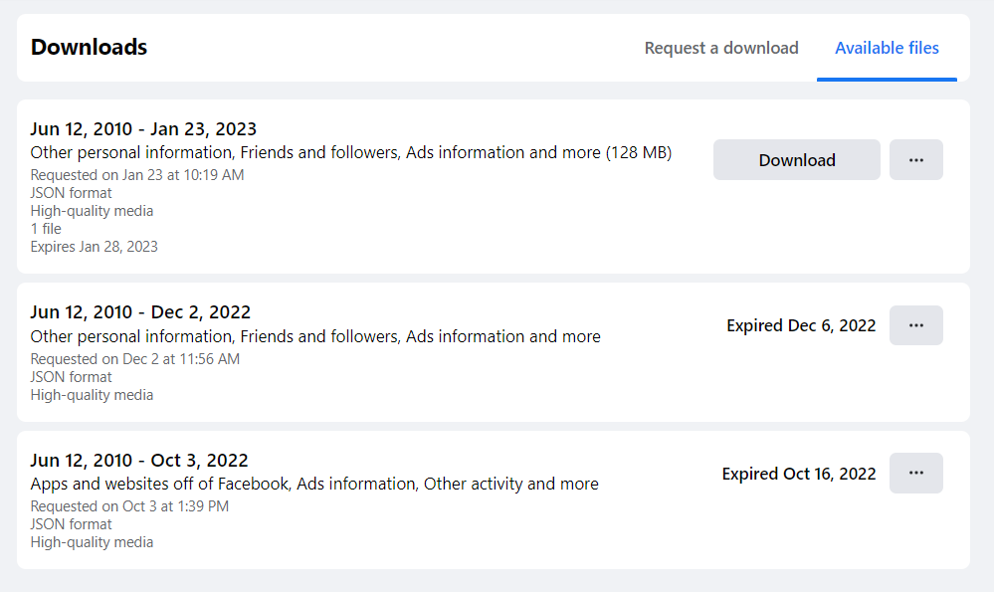
- In the interface that appears, click Download on your latest data request, then enter your Facebook password in the window that appears.
- In the new window that appears, click Confirm.
- Save the offered file. It is important to save the file to a location on your computer where you can find it later!

Instagram
To download the data from your Instagram account, please follow the steps below.
The information in your profile must first be requested on Instagram. You can request the data using a desktop computer or laptop from a web browser.

Start Instagram profile export
- Visit instagram.com in your web browser from a laptop or desktop computer.
- If necessary, log in to the site with your Instagram (Meta) profile.
- The appearance of Instagram may vary slightly from profile to profile. To open the settings, click More in the bottom left corner.
- If you don't see such a menu in the bottom left corner, click on your profile picture in the top right corner and then click on the Settings button in the menu that appears.

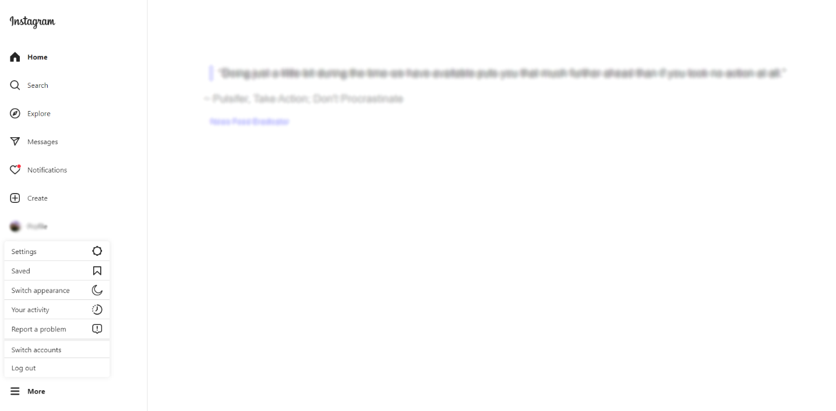
- In the menu bar on the left, click on Privacy and Security.
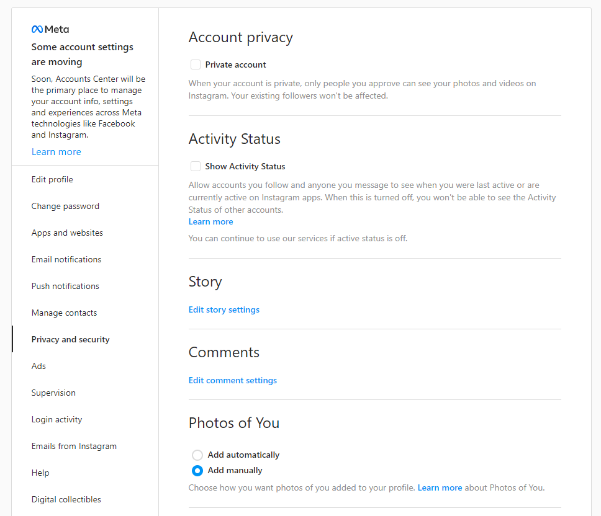
- Scroll down a little and find the Data Download section and click on the Request Download option.
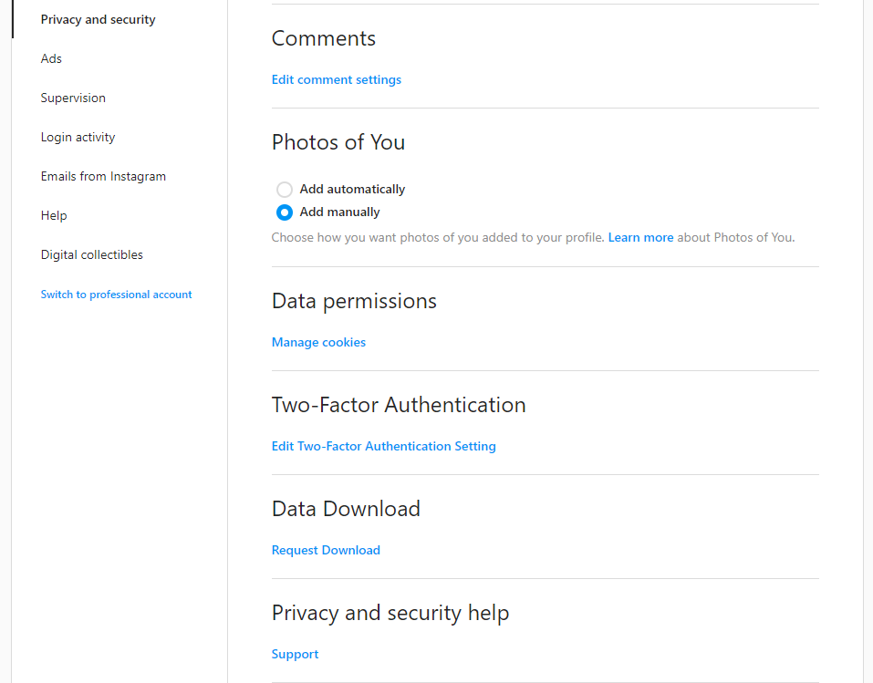
- In the text box on the interface that appears, enter your email address to which Instagram will send a link to download your profile. It is important that you enter an email address that you have access to and that you visit regularly!
- Then select the JSON format from the list! It is important that you choose the JSON format, otherwise, we will not be able to use your data in our research.
- Then press the Next button.
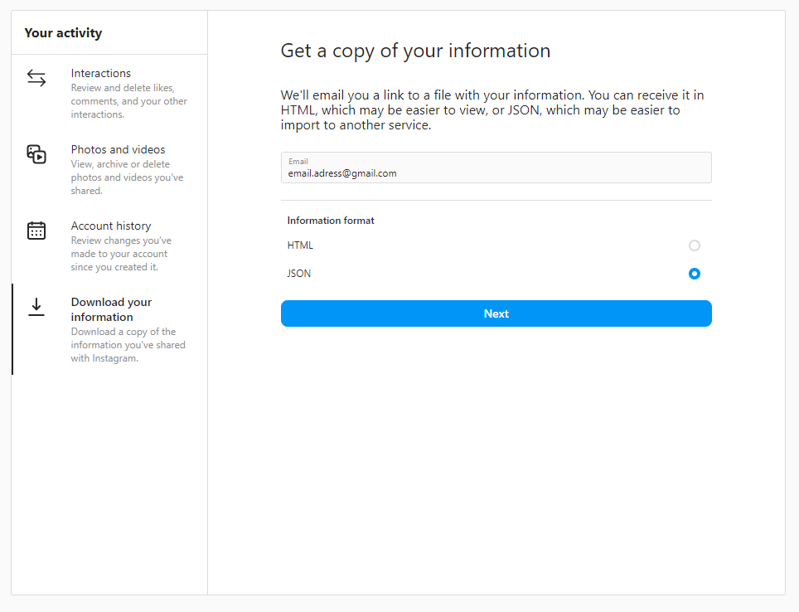
- Finally, in the interface that appears, re-enter the password for your Instagram profile and hit the Request download button.
- You will be able to download your Instagram data when you receive a notification by email to the address you have provided. Depending on the size of your profile, it can take anywhere from a few minutes to 2-3 days for your archive to be available.

Instagram profile archive download
To download your Instagram profile details, you will need an email with the subject Your Instagram information. You will not be able to download your data until you receive this email.
- Open your mailbox and open the email subject Your Instagram information.
- Click on the Download information button in the email.
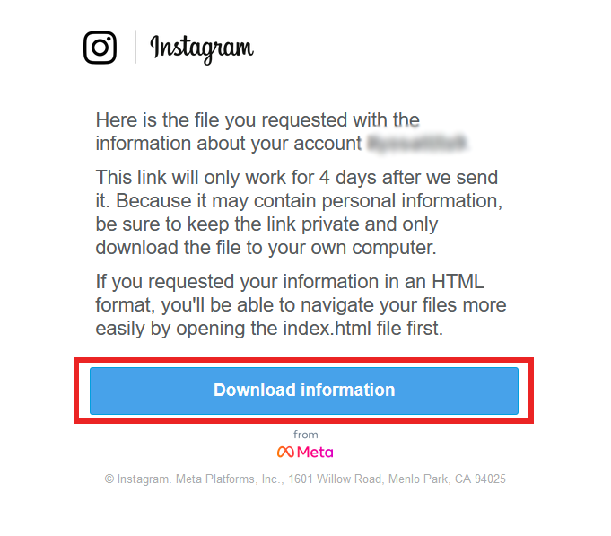
- This will open the Instagram interface in the browser, which will always ask you to sign in. Sign in with your profile details.
- In the interface that appears, click on the Download information button.
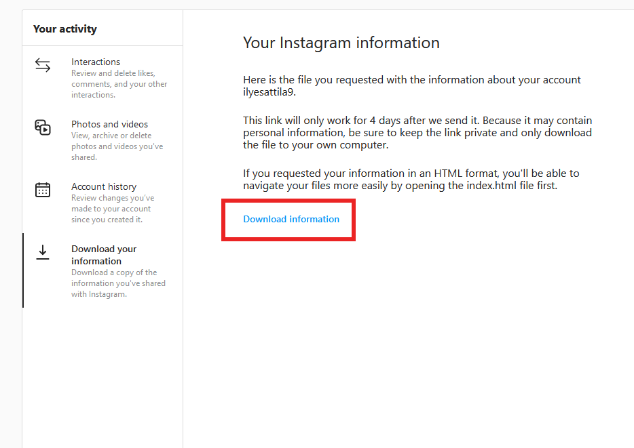
- Save the offered file. It is important that you save the file to a place on your computer where you can find it later!

Google
To download the data in your Google Account, please follow the steps below.
The information in your profile must first be requested from Google Takeout. You can request the data using a desktop or laptop computer from a web browser.
Start Google Takeout export
- Visit the website at https://takeout.google.com/.
- If necessary, sign in with your Google Account.
- As only a small part of the available data is needed for the research, the first step is to click on the Deselect all button.
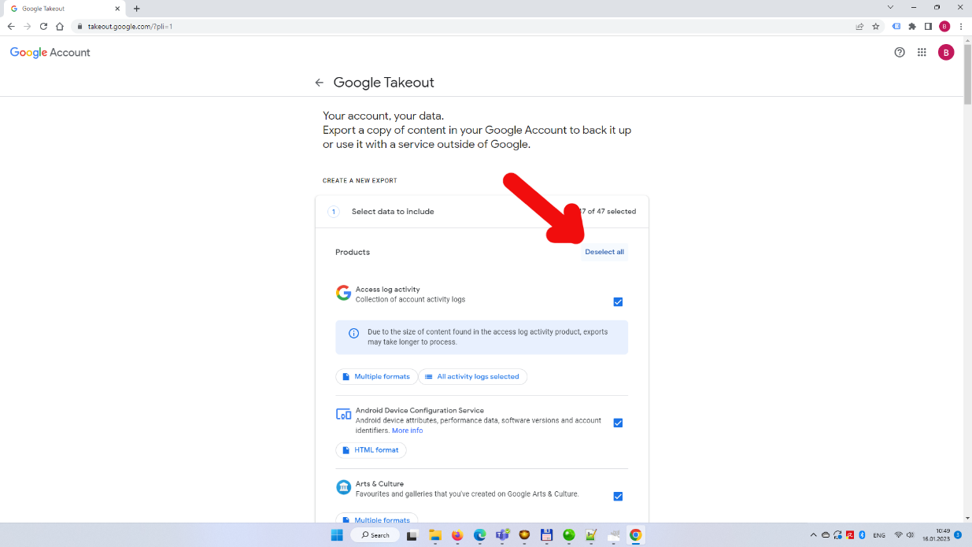
- Select the required data types below. It is important to note that not all data types may be included in your Google profile. In this case, please leave them out. First, scroll down and find and tick the box next to the Location History option.
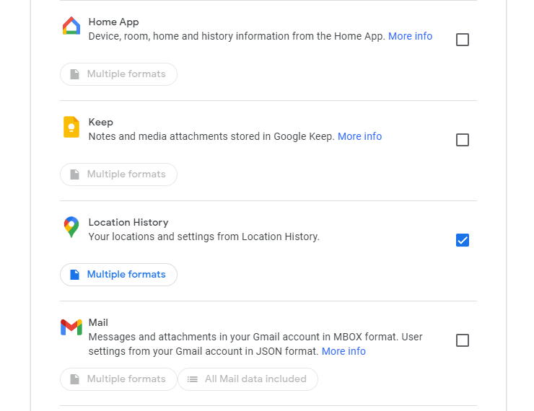
- Then find and tick the box next to My Activity.
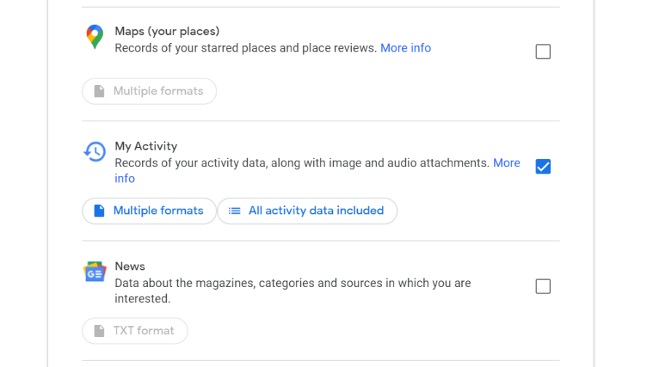
- Still in the My Activity category, click on the Multiple formats button and in the drop-down menu that appears (next to Activity records), select JSON. Then press OK.
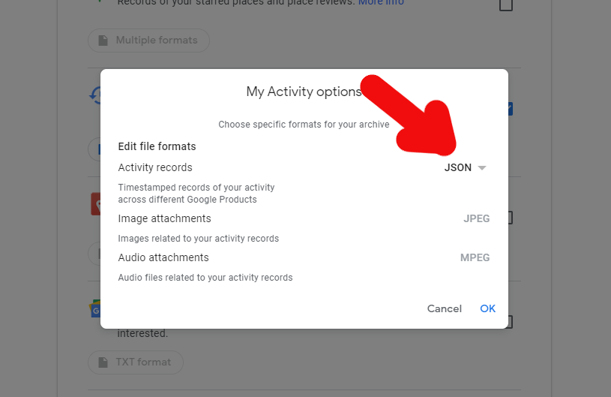
- Still in the My Activity category, click All activity data included, and then click Deselect all at the top of the window that appears. Do not close the window yet.
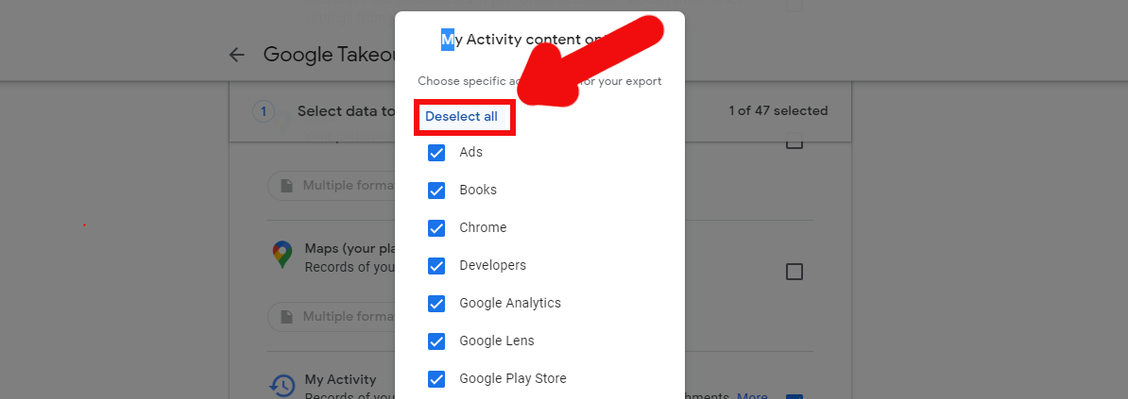
- Then select the Search option from the list, tick the box next to it and click OK.
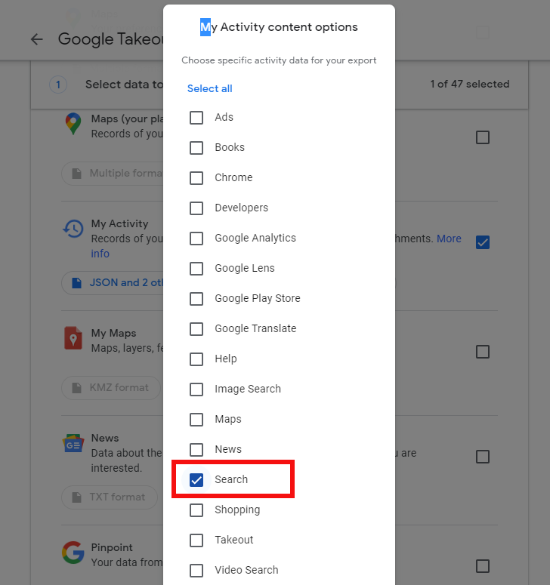

- Next, scroll down to the bottom of the list and tick the checkbox in the YouTube and YouTube Music section, then click the Multiple formats button.
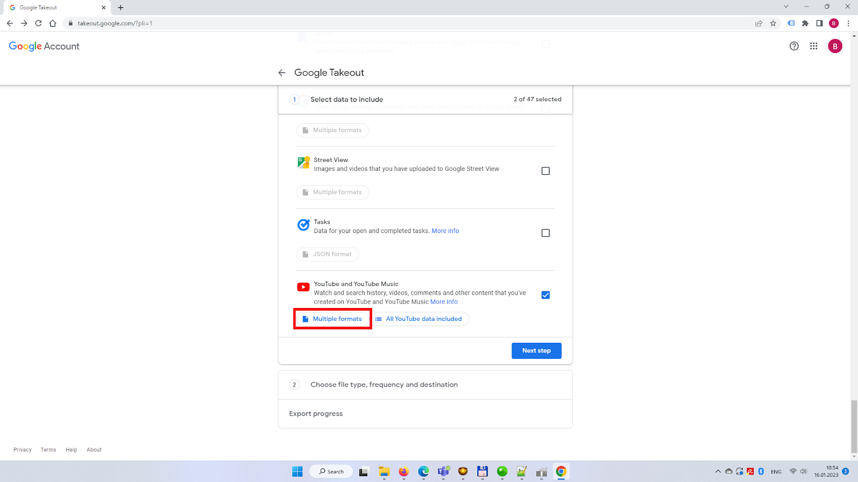
- In the window that appears, select JSON from the drop-down list next to History. Then hit OK.
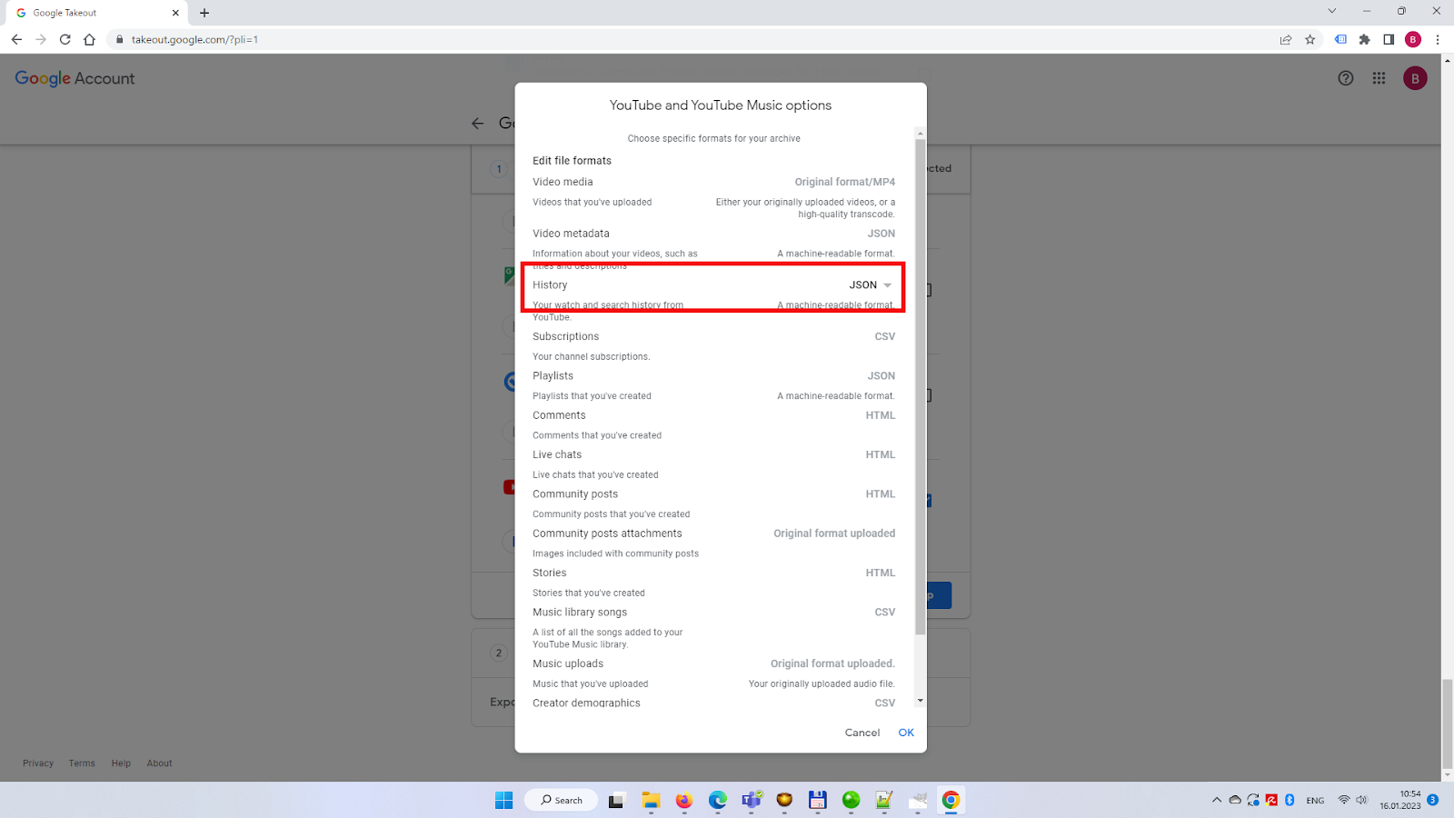
- Click All YouTube data included, then uncheck the checkbox next to the Videos option and hit OK.
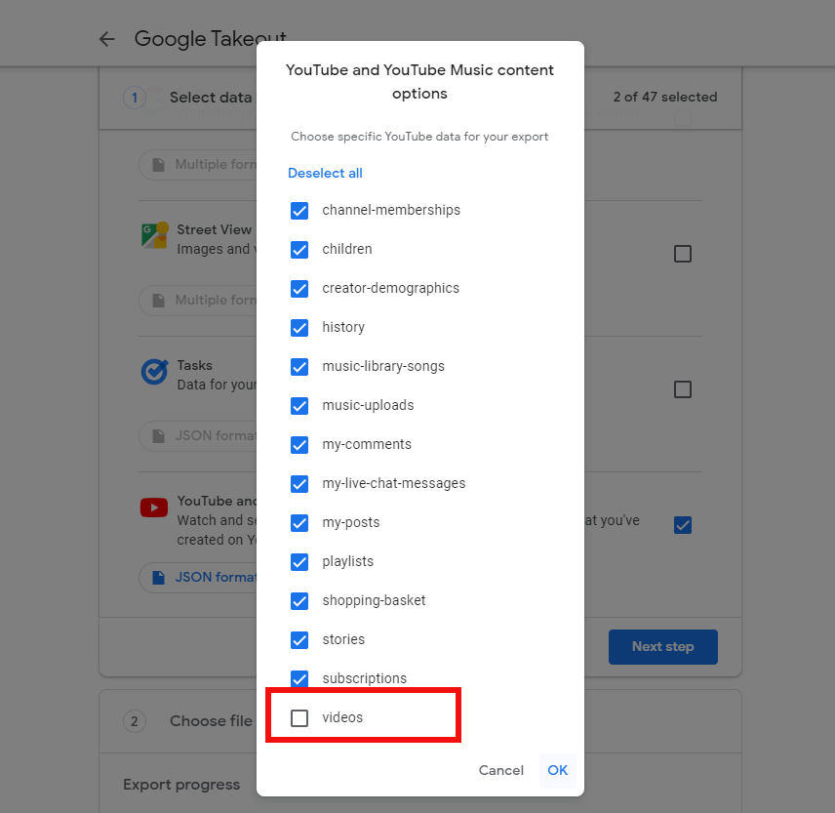

- Click on the Next step button.
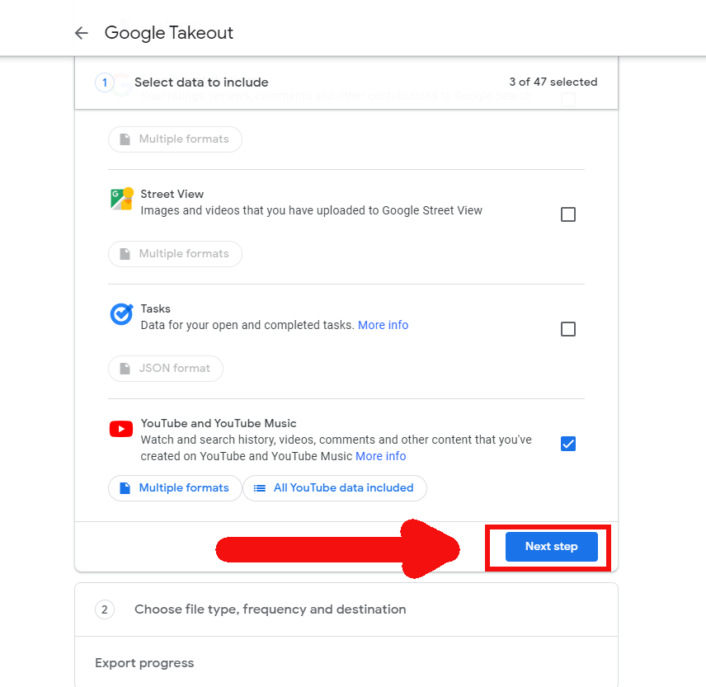
- The settings on the interface that appears do not usually need to be changed, but please make sure that for Destination the option Send download link via email is selected, for Frequency the option Export once is selected, for File type the option .zip is selected, for File size and the option 2GB is selected.
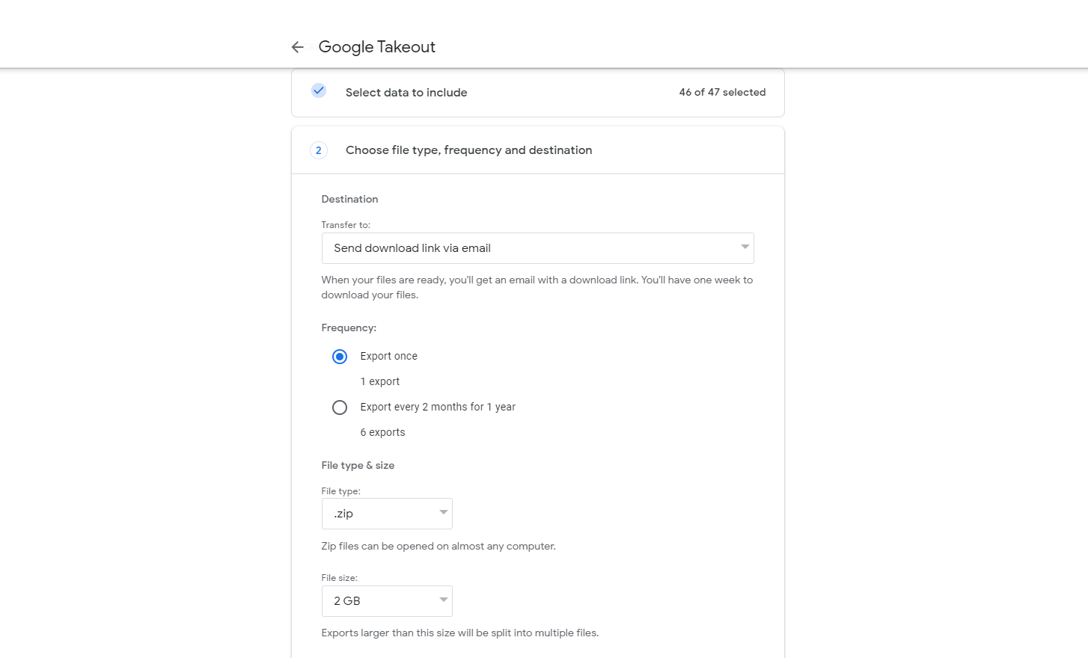
- Once you are satisfied that the settings are correct, please click on the Create export button.
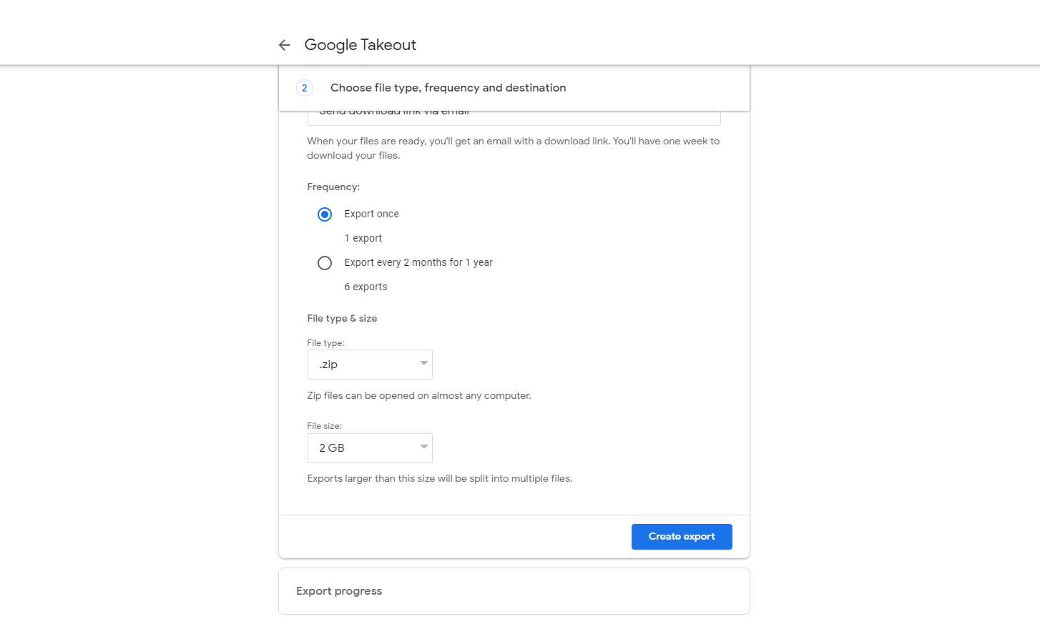
- The export process can take hours or days, depending on the amount of data in your Google profile. You will be notified by email when the export is complete and the files are available for download. Until you receive this notification, you will not be able to download your data.

Download Google Takeout archive
- Open your mailbox and open the email with the subject line Your Google data is ready to download.
- Click on the Download your files button.
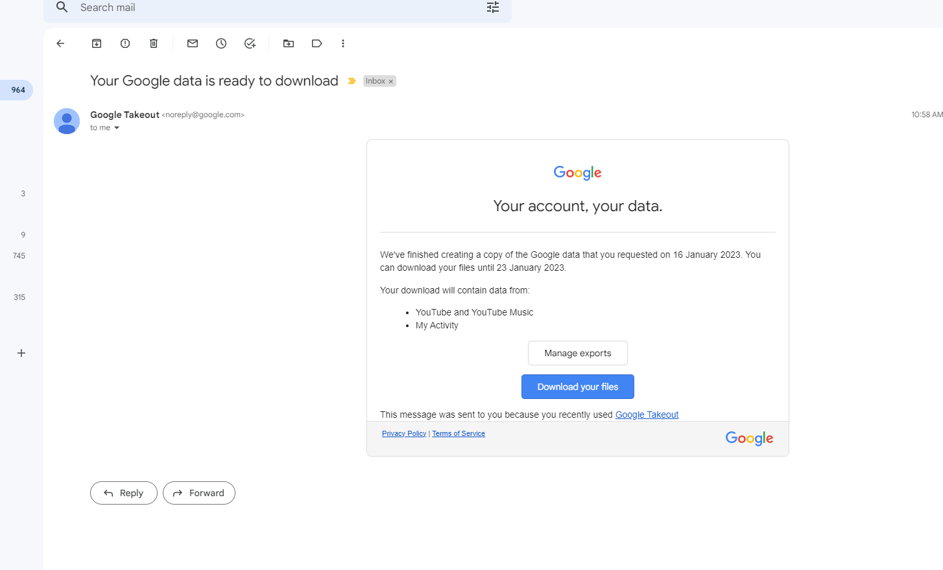
- You will then need to sign in to your Google Account again.
- Once logged in, the download will start automatically. If it does not start, click the Download button on the interface.
- Save the offered file. It is important to save the file to a location on your computer where you can find it later!

TikTok
To download the data in your TikTok account, please follow the steps below.
The information in your profile must first be requested on TikTok. You can request the data using a desktop or laptop computer from a web browser.
Start TikTok export
- Visit tiktok.com in your web browser from a laptop or desktop computer.
- If necessary, log in to the site with your TikTok profile.
- Click on your profile picture at the top right corner, then click on Settings in the menu that appears.
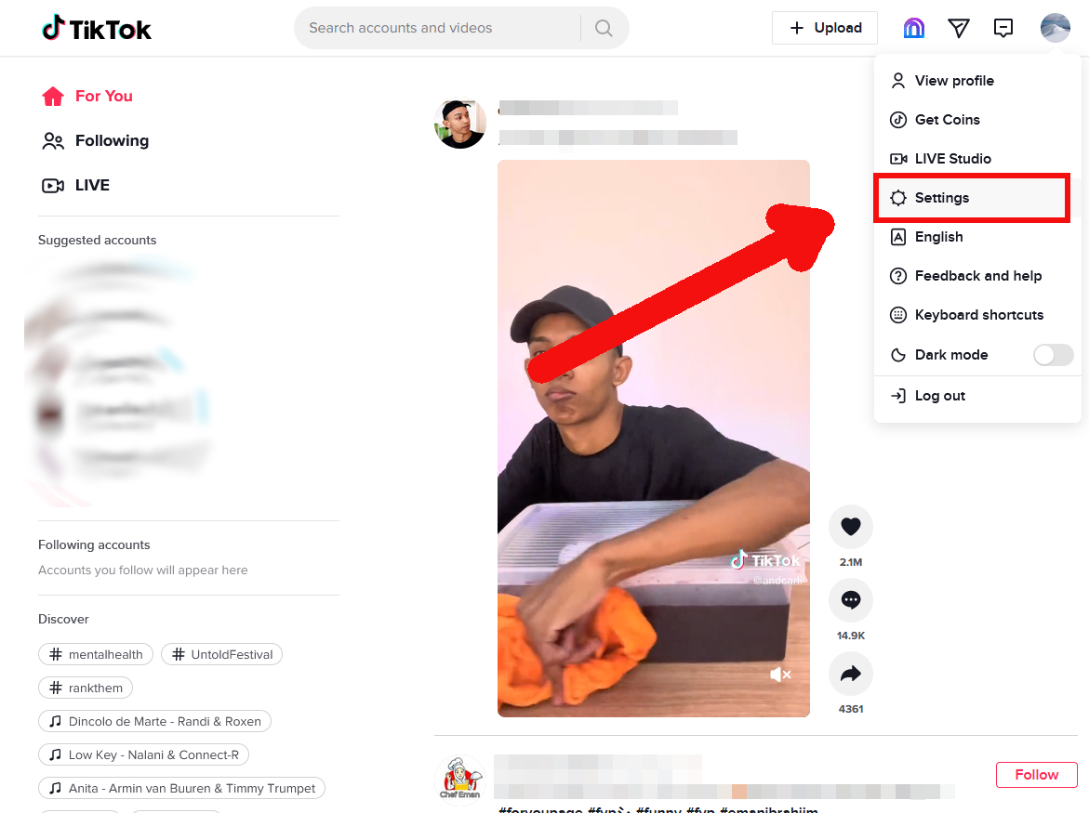
- In the interface that appears, click on the Download your data link.
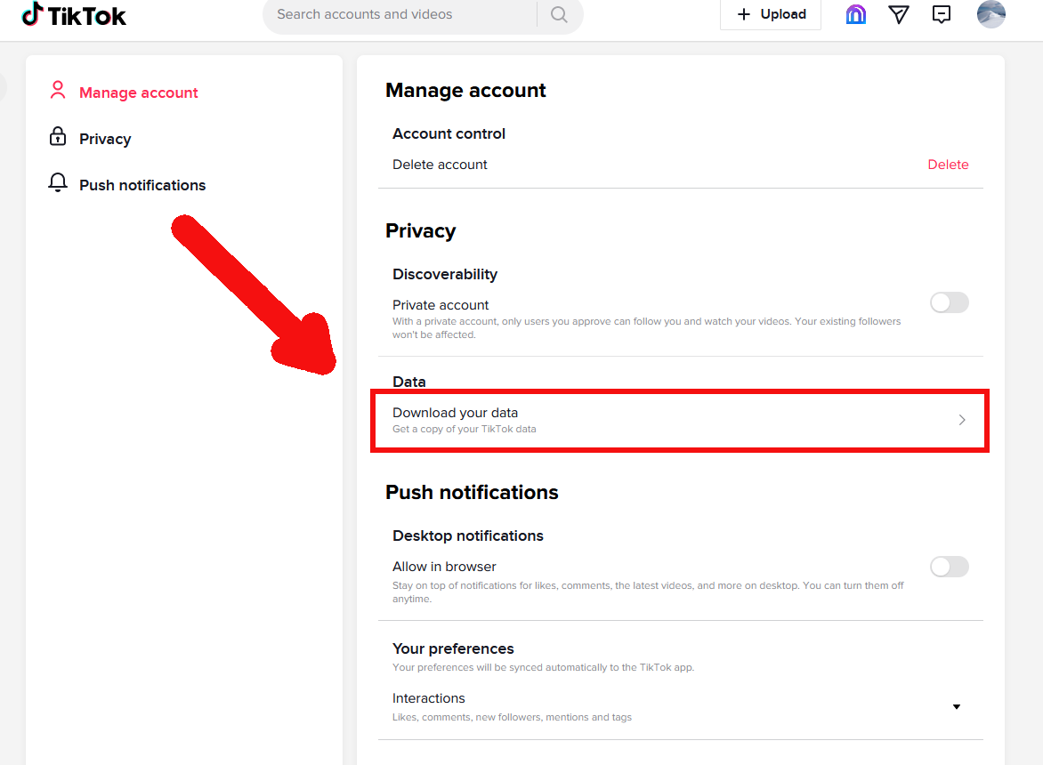
- In the interface that appears, select JSON format in the Select file format section, then press the Request Data button.
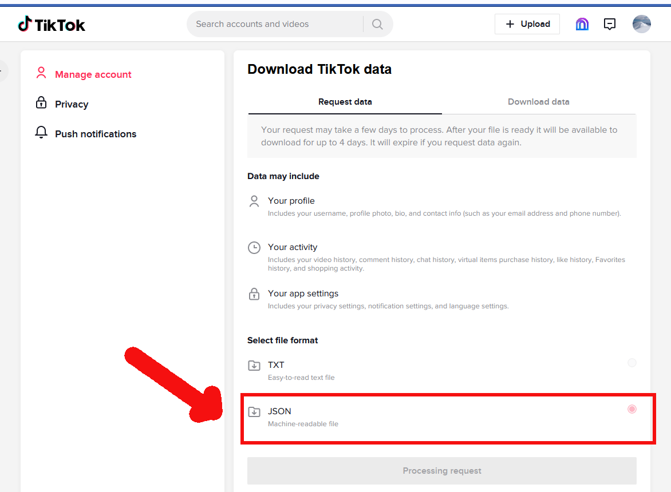
- The export process can take hours or days, depending on the amount of data in your TikTok profile. Note: TikTok does not send a separate notification when the export is complete and the files are ready for download. You can check if the files are available for download by logging into your profile as described above, under the Download Data tab. As long as the Download button on this tab is not activated for your latest data request, you will not be able to download your data.
Download TikTok data
- Visit tiktok.com in your web browser from a laptop or desktop computer.
- If necessary, log in to the site with your TikTok profile.
- Click on your profile picture at the top right, then click on Settings in the menu that appears.
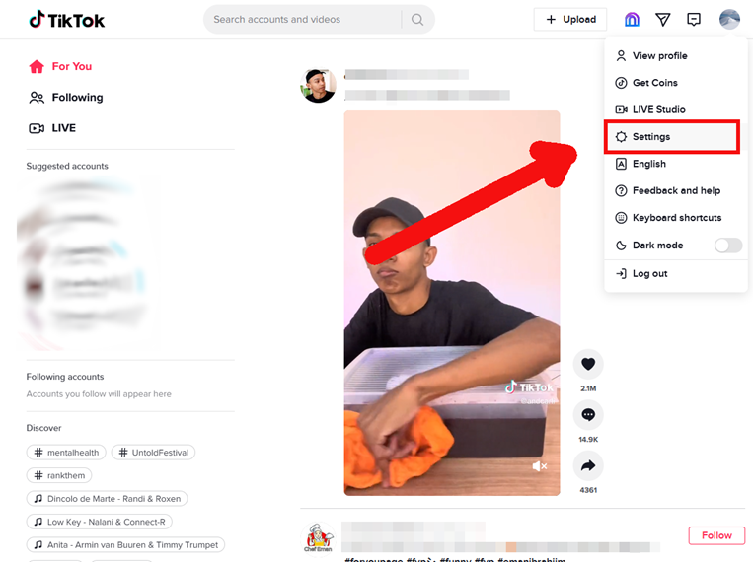
- In the interface that appears, click on the Download your data link.
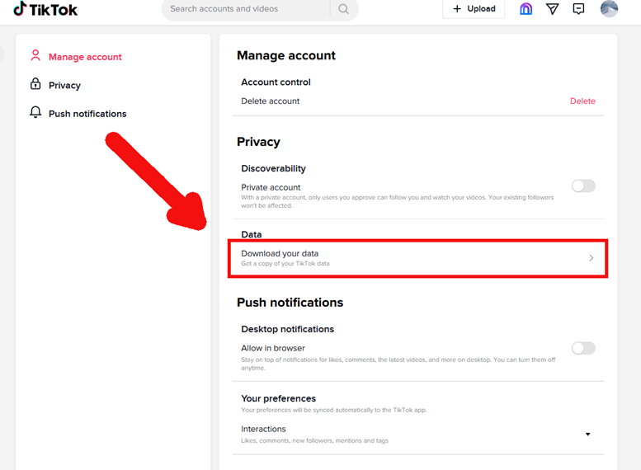
- In the interface that appears, click on the second tab, Download data.
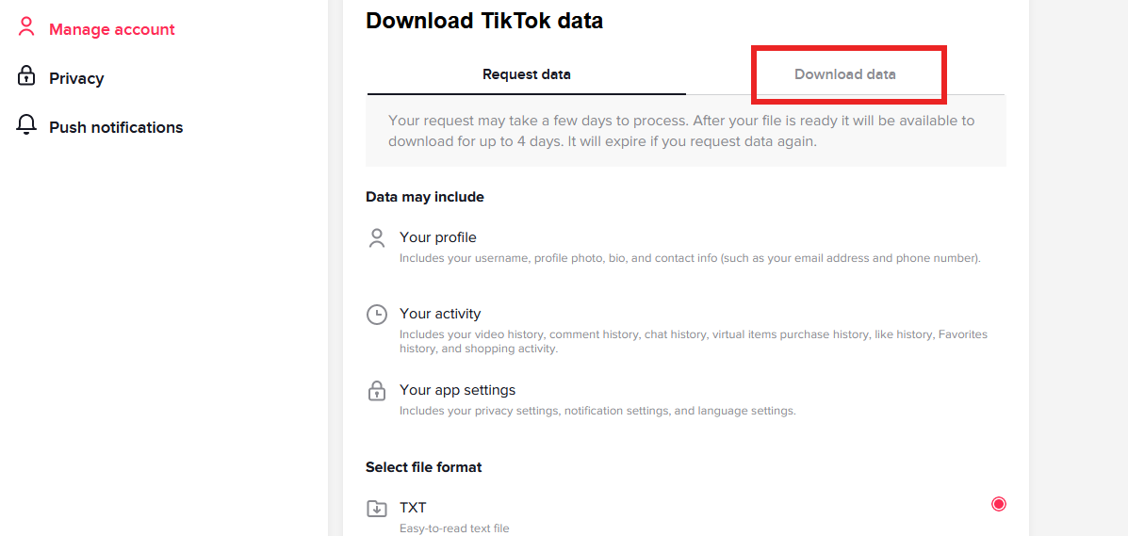
- In the interface that appears, click the Download button in the row of your last (top) data request.
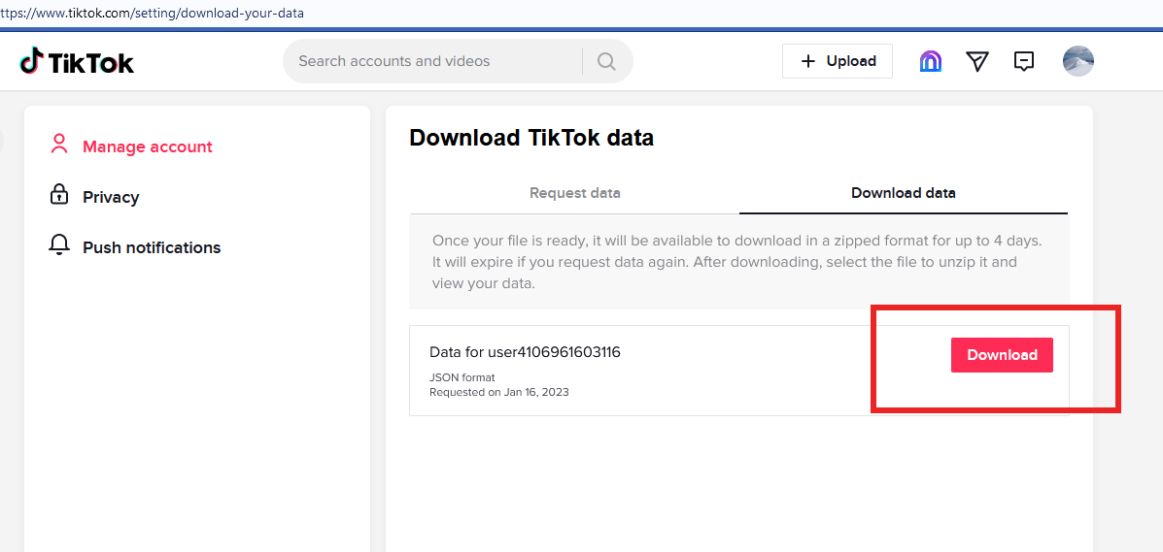
- TikTok is now asking for the password to your profile again. Please enter the password and click Continue.
- Save the offered file. It is important that you save the file to a place on your computer where you can find it later!

Twitter
You do not need to download your Twitter data, as we only use publicly available information on your profile for our research. However, as we can only access this information using your profile username, please follow the steps below to enter your profile username.
- Visit twitter.com in your web browser from a laptop or desktop computer.
- Sign in to the site with your Twitter profile.
- At the bottom of the left-hand sidebar is the your published name on Twitter, and below that, after the @ sign, your Twitter username.
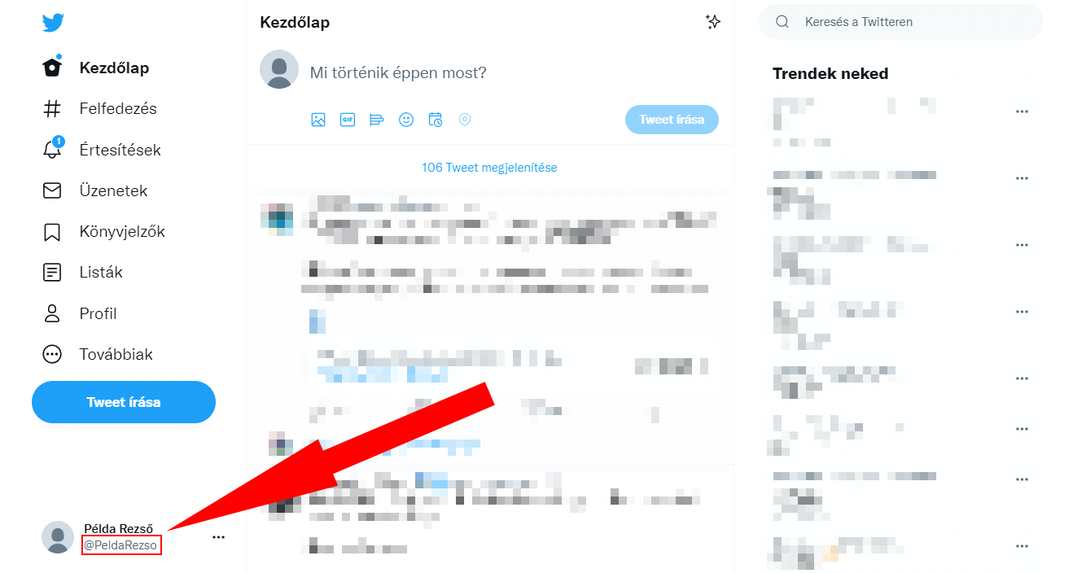
- Please enter your Twitter username, i.e. the part after the @ (in this case: PeldaRezso).

